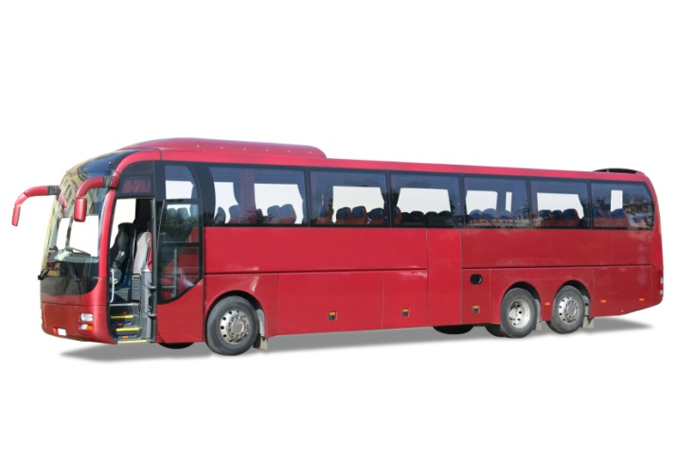In this activity you will use Excel to draw line graphs which show the connection between variables in real situations. You will also study how features of the graphs are related to the information used to draw them.

Information sheet

The cost of hiring a coach consists of a basic charge of £60 plus £30 per hour.

You can use an Excel spreadsheet to calculate the total cost for hiring the coach for different times.

A graph can then be drawn to illustrate the relationship between the total cost and the time.

Try this …

A To draw a line graph showing the connection between the time and cost

**1** First ***find a formula*** that relates the total cost to the time for which the coach is hired.

The total cost is £60 plus £30 per hour.

Think about

For *h* hours the total cost in £ is given by *C*= 60 + 30*h.*   
Can you explain this formula?

**2** Use the formula to ***set up a spreadsheet table***.

Put headings *h* (for number of hours) and *C* (for cost in £) at the top of columns A and B.

To use 0 as the first value of *h*, enter 0 in cell A2.

See formulae below.

Write a spreadsheet version of the formula in cell B2 to calculate the cost.

Write a spreadsheet formula in cell A3 to calculate the next value of *h*.

|  |  |  |  |  |  |  |  |  |
| --- | --- | --- | --- | --- | --- | --- | --- | --- |
|  | A | **B** | **C** |  |  | A | **B** | **C** |
| **1** | ***h*** | C |  |  | **1** | ***h*** | C |  |
| **2** | 0 | 60 |  |  | **2** | 0 | =60+30*A2 |  |
| **3** | 1 |  |  |  | **3** | =A2+1 |  |  |

Numerical values

Formulae

**3** Use ‘***fill down***’ to complete the table as far as *h* = 8.   
The results are shown below.

|  |  |  |  |  |  |  |  |  |
| --- | --- | --- | --- | --- | --- | --- | --- | --- |
|  | A | **B** | **C** |  |  | A | **B** | **C** |
| **1** | ***h*** | C |  |  | **1** | ***h*** | C |  |
| **2** | 0 | 60 |  |  | **2** | 0 | =60+30*A2 |  |
| **3** | 1 | 90 |  |  | **3** | =A2+1 | =60+30*A3 |  |
| **4** | 2 | 120 |  |  | **4** | =A3+1 | =60+30*A4 |  |
| **5** | 3 | 150 |  |  | **5** | =A4+1 | =60+30*A5 |  |
| **6** | 4 | 180 |  |  | **6** | =A5+1 | =60+30*A6 |  |
| **7** | 5 | 210 |  |  | **7** | =A6+1 | =60+30*A7 |  |
| **8** | 6 | 240 |  |  | **8** | =A7+1 | =60+30*A8 |  |
| **9** | 7 | 270 |  |  | **9** | =A8+1 | =60+30*A9 |  |
| **10** | 8 | 300 |  |  | **10** | =A9+1 | =60+30*A10 |  |

Numerical values

Formulae

**4** To draw the graph, highlight the values in columns A and B and **Insert a** **Scatter Graph** (choose the line with points).

Click on **Layout 1** to give the graph a title and axis labels.

Think about

Why is the graph linear?

Your graph should be ***linear***.   
This means that the graph is a ***straight line***.

B To format the graph

Follow these instructions to give the graph shown on the next page.

**1** Delete the legend (key), as this is not needed when there is only one line.

**2** Right click on the **Chart Title**, then each **Axis Title** and select **Edit Text** to change them.

**3** To add more gridlines to the graph, click on **Chart Tools Layout Gridlines.**In both **Primary Horizontal Gridlines** and **Primary Vertical Gridlines** select **Major and Minor Gridlines.**

If you wish, you can also change the colour and thickness of the gridlines.   
To do this, go to the **More Options** section at the bottom of each gridlines menu.

**4** To change the scale on each axis, right click on it, then select **Format Axis**.

On the **Axis Options** menu, click on **Fixed,** then change each value to those given below:

Horizontal axis Vertical axis

8 300

1 50

0.25 (so each small square = ¼ hour) 10

**5** **Print your graph** and use it for section C which follows.

C Relating features of the graph to the information used to draw it

The **intercept on the *y* axis** is the value of *y* where the line meets the vertical axis.  
This is 60 on the graph below. Check that the intercept is 60 on your graph too.

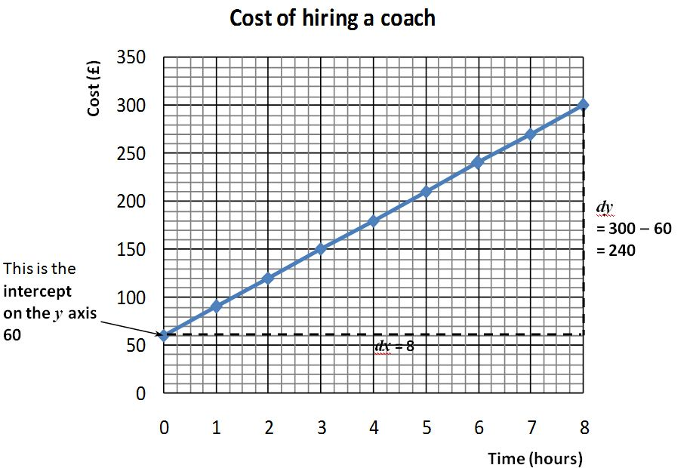

The **gradient** (sometimes called slope) of a line is a measure of how steep it is.

Follow these instructions to find the gradient of your line:

Draw a triangle between two points on the line (shown as dotted lines above).

Find the distance in the *y* direction (*dy*) and the distance in the *x* direction (*dx*).

Divide the distance in the *y* direction (*dy*) by the distance in the *x* direction (*dx*).



On the graph above the gradient = 30.

***Check that the gradient*** of your line agrees with this.

Think about

What connections are there between the intercept and gradient of the line, the original information and the formula used to draw the line?

Cherry dessert production line

Information

On the cherry dessert production line, 15 minutes is spent on setting up the equipment before production can start. After the production process starts, it takes 12 seconds to produce each dessert.

Try this …

A To draw a line graph showing the connection   
between the number of desserts and the time taken to make them

**1** First ***find a formula*** that relates the time to the number of desserts.  
It is important to be consistent with the units used for time.   
Note that 12 seconds =  minutes

The total production time is 15 minutes plus 0.2 minutes for each dessert.

Think about

For *n* desserts the total time is given by .  
Can you explain this formula?

**2** Use the formula to ***set up a spreadsheet table***.

Put headings *n* (for number of desserts) and *T* (for time in minutes) at the top of columns A and B.

To use 0 as the first value of *n*, enter 0 in cell A2.

Write a spreadsheet version of the formula in cell B2 to calculate the time.

See formulae below.

Write a spreadsheet formula in cell A3 to calculate the next value of *n*.

|  |  |  |  |  |  |  |  |  |
| --- | --- | --- | --- | --- | --- | --- | --- | --- |
|  | A | **B** | **C** |  |  | A | **B** | **C** |
| **1** | ***n*** | ***T*** |  |  | **1** | ***n*** | ***T*** |  |
| **2** | 0 | 15 |  |  | **2** | 0 | =15+0.2*A2 |  |
| **3** | 50 |  |  |  | **3** | =A2+50 |  |  |

Numerical values

Formulae

**Take care to extend *your* table to *n* = 1000**

**3** Use ***‘fill down’*** to complete the table as far as *n* = 1000.

The first few rows are shown below.

|  |  |  |  |  |  |  |  |  |
| --- | --- | --- | --- | --- | --- | --- | --- | --- |
|  | A | **B** | **C** |  |  | A | **B** | **C** |
| **1** | ***n*** | T |  |  | **1** | ***n*** | T |  |
| **2** | 0 | 0 |  |  | **2** | 0 | =15+0.2*A2 |  |
| **3** | 50 | 25 |  |  | **3** | =A2+50 | =15+0.2*A3 |  |
| **4** | 100 | 35 |  |  | **4** | =A2+50 | =15+0.2*A4 |  |
| **5** | 150 | 45 |  |  | **5** | =A2+50 | =15+0.2*A5 |  |
| **6** | 200 | 55 |  |  | **6** | =A2+50 | =15+0.2*A6 |  |
| **7** | … | ….. |  |  | **7** | …. | ….. |  |

Numerical values

Formulae

**4** To draw the graph, highlight the values in columns A and B and **Insert a** **Scatter Graph** (choose the line with points).  
Click on **Layout 1** to give the graph a title and axis labels.   
Follow the instructions in section B to format the graph.

B To format the graph

**1** Change the title and labels, remove the legend and include both major and minor gridlines.

**2** ***Apply the following scales****:*

Number of desserts axis - major gridlines at intervals of 200,   
 - minor gridlines at intervals of 20

Total time axis - major gridlines at intervals of 50,   
 - minor gridlines at intervals of 5

**3** ***Print your graph***.

C Relating features of the graph to the information used to draw it

Find the intercept and gradient of the line.

Explain what relationships your answers have with the original information and the formula for *T*.

Heating oil

Information

A tank is filled with 50 gallons of oil. The oil is used at a rate of half a gallon per hour to heat a building.

Try this …   
To draw a line graph and relate it to the real situation

**1** First ***find a formula***.

Think about

0.5 gallon is used each hour, so the number of gallons *left* after *h* hours is given by   
*G* = 50 – 0.5*h*.

Can you explain this formula?

**2** Use the formula to ***set up a spreadsheet table***.  
 Use values of *h* from 0 to 100 at intervals of 10 hours.

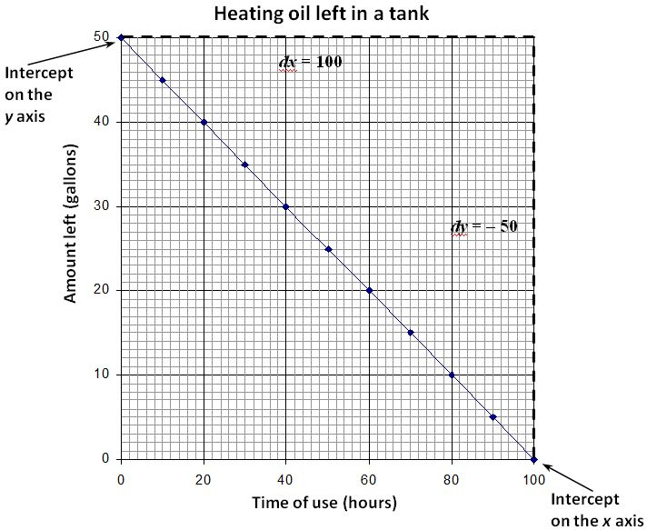**3** ***Draw a graph, format it to look like the graph below,   
then print it.***

***dy* = – 50**

Think about

* What is the intercept on the *y* axis? How does it relate to the real situation?
* What is the intercept on the *x* axis? How does it relate to the real situation?
* Why is the value of *dy* negative?
* What is the gradient and how does it relate to the real situation?

The answers to these questions are given on the next page.

The intercept on the *y* axis gives the initial amount of oil in the tank, 50 gallons.

The intercept on the *x* axis, 100 hours, is the time when there is no oil left.

*dy* is negative because the line is going down from left to right (the amount of oil in the tank is decreasing).

Gradient (slope) of this line =  = – 0.5



The gradient gives the rate at which the amount of oil is changing, – 0.5 gallons per hour.

This rate is ***negative*** because the amount of oil in the tank is ***reducing*** as time goes by.

Summary

The **intercept on the *y* axis** is the value of *y* where the line meets the vertical axis.

It gives the starting value and is equal to the ***constant*** in the formula.

For example, in the formula for the cost of hiring a coach, *C*= 60 + 30*h,*  
£60was the basic charge for hiring the coach.

The **gradien t**(slope) of a line is a measure of how steep it is.

To find the gradient of a line, draw a triangle between 2 points on the line and divide the distance in the *y* direction (*dy*) by the distance in the *x* direction (*dx*).  
The gradient of the line is equal to the ***coefficient of x*** in the formula.

In the coach example, *h* was on the *x* axis and £30 was the charge rate per hour.

At the end of the activity

Does it cost twice as much to hire the coach for 4 hours as it does for   
2 hours? Explain your answer.

How would the ‘Hire a coach’ formula and graph change if the hourly rate went up to £35 an hour?

How would the ‘Hire a coach’ formula and graph change if the basic charge went down from £60 to £50?

Can you think of other situations that would produce similar looking graphs?

In general, how do the intercept on the *y* axis and gradient relate to the formula and the real context?

Extension

Another coach hire company quotes a basic charge of £30 + £40 per hour. Add another column to your first spreadsheet so that you have two lines on your graph. Which firm gives the better deal?