Student worksheet: Try these
Fill in the table to find out how much is in each account after one year.
(Round to the nearest pence where necessary.)

 | Amount in account | Interest rate | Calculated interest | Amount in account at end of year
1 | £120 | 3.1 % | 120 × 0.031= £3.72 | £123.72
2 | £350 | 5.4 %
3 | £255 | 4.2 %
4 | £430 | 3.5 %
5 | £290 | 2.6 %
6 | £305 | 2.4 %
7 | £680 | 5.1 %
8 | £550 | 4.9 %
9 | £624 | 4.5 %
10 | £593 | 5.1 %
11 | £936 | 5.6 %
12 | £1235 | 2.5 %
13 | £1235 | 2.6 %
14 | £2000 | 3.9 %
15 | £3500 | 5.3 %

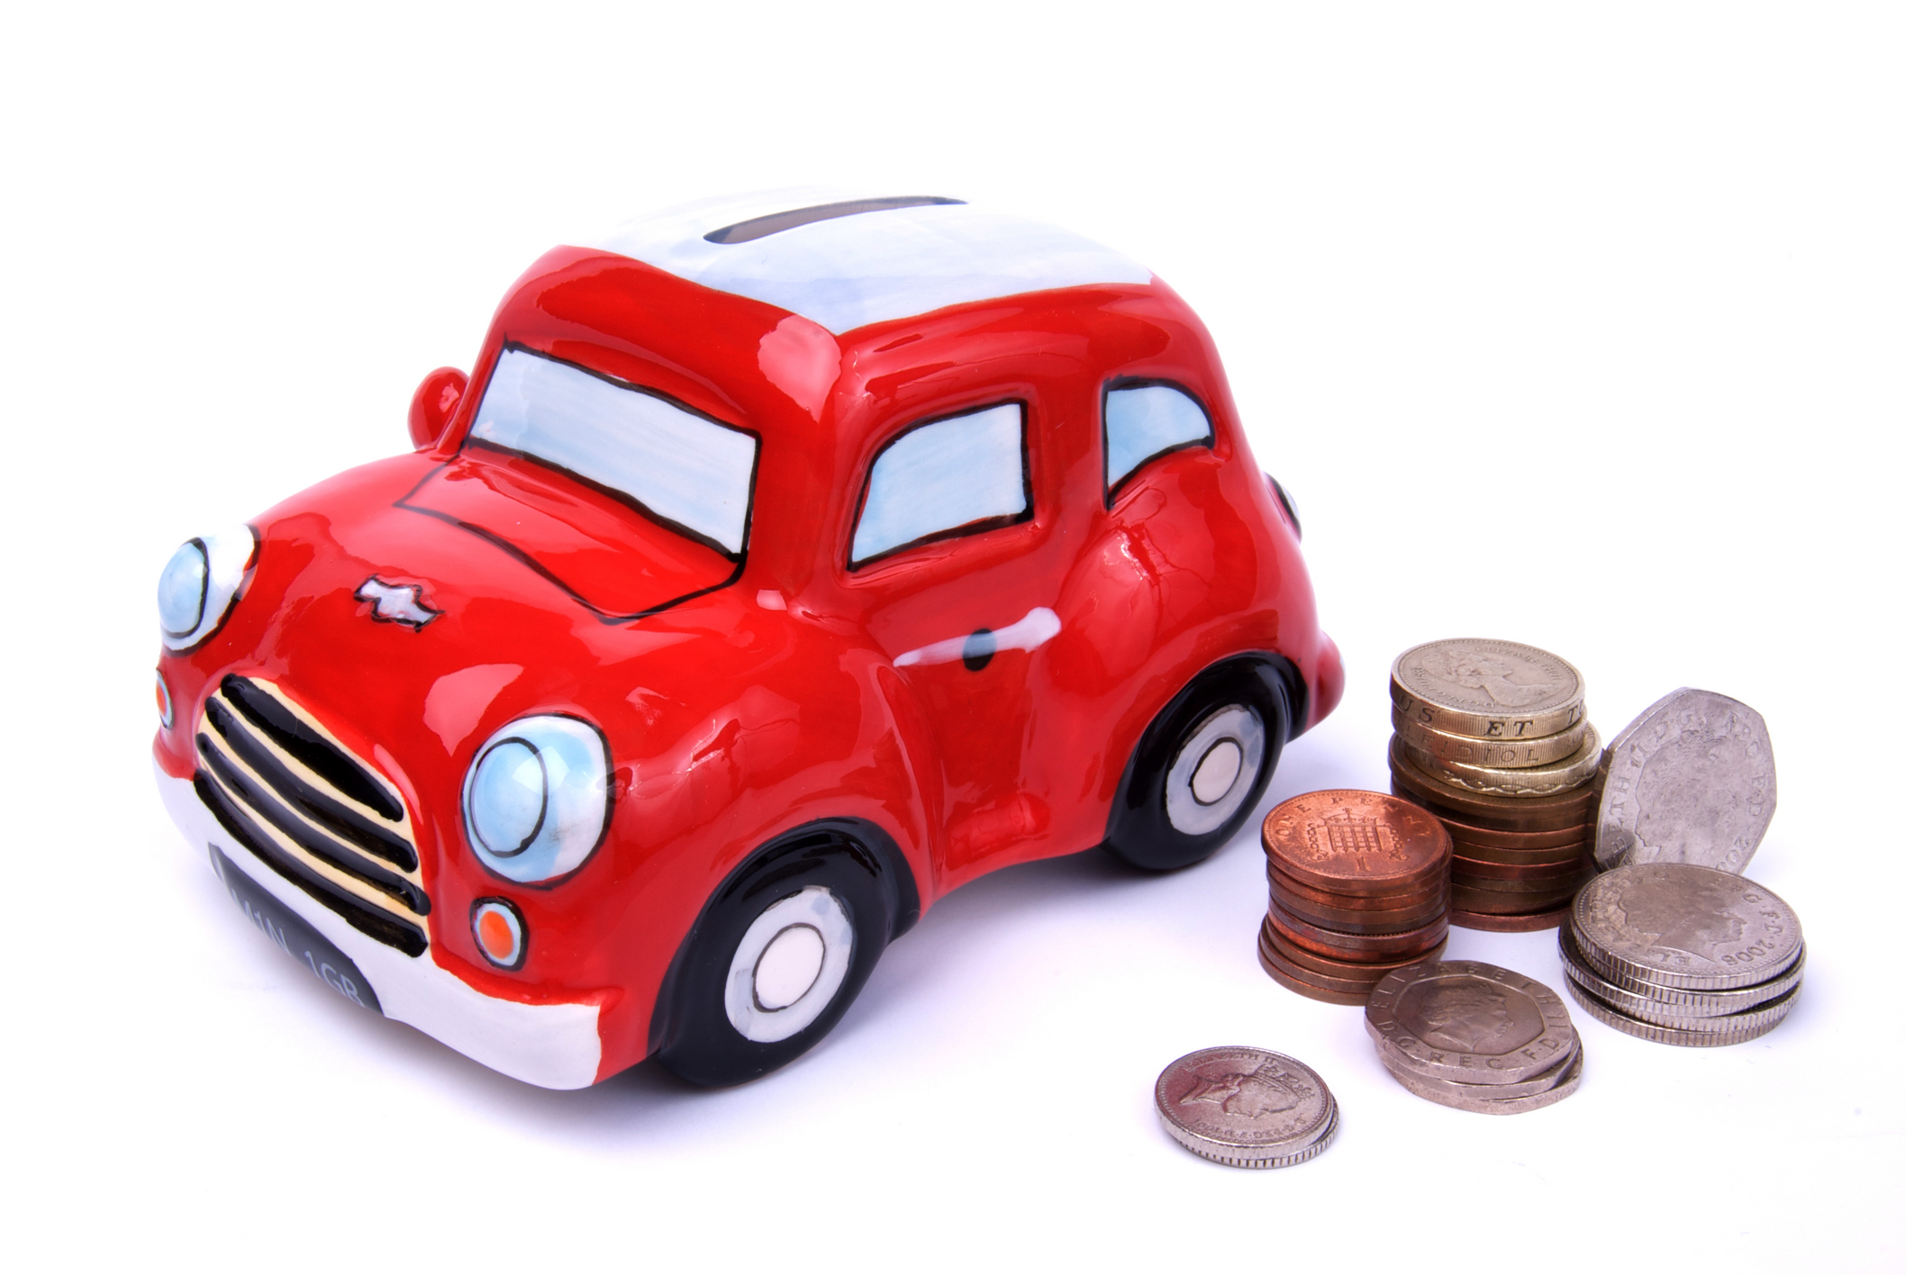
Think about
What happens to interest if you put more money in the bank?
What happens to interest if the interest rate goes down?
Compound interest: Try these
Now find out what happens if you leave your money in the
account for several years.
Fill in the tables.
 | Amount £ | Interest % | Interest £ | End of year
Year 1 | £400 | 5 %
Year 2 |  | 5 %
Year 3 |  | 5 %
Year 4 |  | 5 %
Year 5 |  | 5 %

 | Amount £ | Interest % | Interest £ | End of year
Year 1 | £150 | 3 %
Year 2 |  | 3 %
Year 3 |  | 3 %
Year 4 |  | 3 %
Year 5 |  | 3 %

 | Amount £ | Interest % | Interest £ | End of year
Year 1 | £950 | 3.4 %
Year 2 |  | 3.4 %
Year 3 |  | 3.4 %
Year 4 |  | 3.4 %
Year 5 |  | 3.4 %
Think about
What happens to the interest each year?
Investigate other accounts

Bank: ……………………………………………………………
 | Amount £ | Interest % | Interest £ | End of year
Year 1
Year 2
Year 3

Bank: ……………………………………………………………
 | Amount £ | Interest % | Interest £ | End of year
Year 1
Year 2
Year 3

Bank: ……………………………………………………………
 | Amount £ | Interest % | Interest £ | End of year
Year 1
Year 2
Year 3
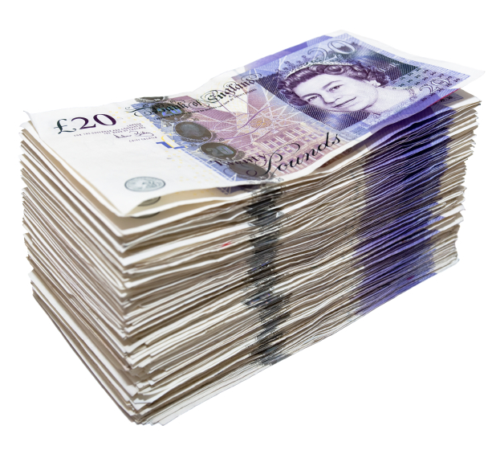
At the end of the activity
Why is it better to save in a bank or building society than in
a money box?
How do you decide which account offers the best rate of interest?
What happens to interest if you leave money in an account? Why?

