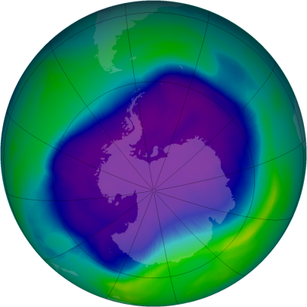
In this activity you will suggest functions that could be used to model real data and consider how well the functions do this.
Information sheet
At ground level ozone is a health hazard, but the layer of ozone in the stratosphere (between 10 kilometres and 50 kilometres above the Earth’s surface) provides a valuable shield against harmful ultraviolet radiation from the Sun.
Year | Maximum area of ozone hole  (million km²)
1980 | 3.3
1981 | 3.1
1982 | 10.8
1983 | 12.2
1984 | 14.7
1985 | 18.8
1986 | 14.4
1987 | 22.5
1988 | 13.8
1989 | 21.7
1990 | 21.1
1991 | 22.5
1992 | 24.9
1993 | 25.8
1994 | 25.2
1996 | 26.9
1997 | 25.1
1998 | 27.9
1999 | 25.8
2000 | 29.9
2001 | 26.5
2002 | 21.9
2003 | 28.4
2004 | 22.7
2005 | 26.9
2006 | 29.3
2007 | 24.8
2008 | 26.5
2009 | 24.0
2010 | 22.2
Ozone levels are monitored from the ground, air and Space.
Ozone levels vary periodically with the seasons.
In an area over the Antarctic, levels of ozone fall so low in spring that scientists describe the loss as the ‘ozone hole’.
The amount of ozone above a point on the Earth’s surface is measured in Dobson Units (DU). This measurement represents the thickness of the ozone layer if all the ozone molecules overhead could be brought down to the Earth’s surface.
The average ozone layer thickness is about 300 DU (3 mm). There is said to be an ‘ozone hole’ where the thickness is less than 220 DU.
The table shows the maximum area of the Antarctic ozone hole for each year from 1980 to 2010. (There is no figure for 1995 when no measurements were taken.)
Think about
How does the size of the ozone hole vary over these years?

Finding possible models
The graph below illustrates the data given on the information sheet.

Try these
1 List types of functions you think might provide suitable models for this data.
2 Use a graphic calculator or computer to find two or more models.
3 For each of your models investigate:
- how well the model fits the data given on the Information sheet.
- what the model predicts for future years.

